Ikimina System project dfd

By using dfd we can easly understand the overall functionality of the ststem because it represents the incoming data flow, out going dataflow and store the data

1. **List of activities:**

.Initiate a tontine (Explaini and introducing it people)

.Enroll members (Members registration)

.Contribute funds (members pay money after pre agreed time)

.Organise Regural zoom tontine meetings

.LOans application

.Offering money to a member after sometime ( a member will be choosen landomly)

. Interests and funds calculation

1. **Contextual level:**

**(Level 0)-**

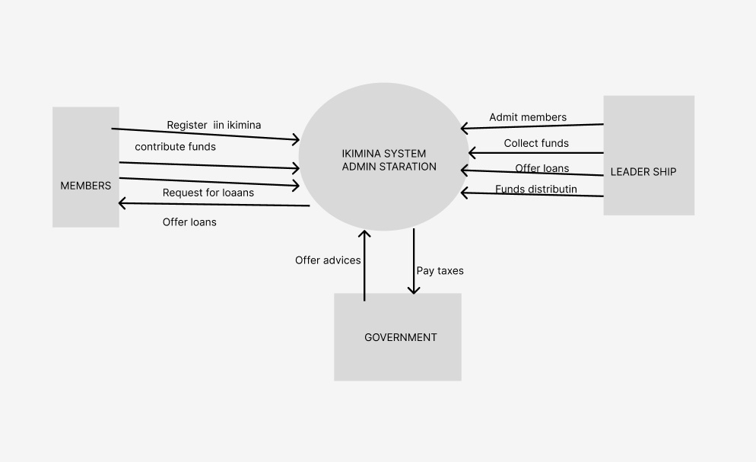

It is the diagram that provides the entire system data flow and process with a single process

=>Membership

=>Funds contribution

=>Loans application

=>Funds distribution

1. **Level 1**

It is more detailed version that includes databases,